Design and Testing of the Attitude Determination and Control System (ADCS) for Ukpik-1

**Phase I Report**

Joshua Vander Doelen 250 896 651

Michael Bruhjell 250 836 469

Shaemus Tracey 250 841 785

Zachary Mullins 250 849 298

Word Count: 5986

**Table of Contents**

Executive Summary 1

1 Introduction 2

2 Background Information 3

2.1 Relevant Mathematical Concepts 3

2.1.1 Reference Frames 3

2.1.2 Dynamic Equation of Motion 3

2.2 Actuator Selection 5

2.3 Actuator Manufacturing 6

3 Scope, Constraints & Objectives 7

3.1 Scope 7

3.2 Objectives and Constraints 8

3.2.1 Magnetorquer 8

3.2.2 Magnetorquer Manufacturing 9

4 Concept Generation & Selection 9

4.1 Magnetorquer Design 9

4.2 Magnetorquer Manufacturing Apparatus Design 12

5 Design Validation 15

5.1 Project Scoping and Planning 15

5.2 Magnetorquer Design 16

5.3 Torque Validation 19

5.3.1 Disturbance Torques 19

5.3.2 Control Torque 22

5.4 Magnetorquer Manufacturing Apparatus Design 23

5.5 System Testing and Control System Development 23

6 Progress, Schedule & Planning 24

7 Resources & Budget 25

8 Conclusions & Recommendations 26

Appendix 27

References 30

# Executive Summary

The following report describes the current progress to date on the design, manufacturing and testing of the Attitude Determination and Control System (ADCS) of the Ukpik-1 CubeSat being developed by Western University in partnership with Nunavut Arctic College. The mission of the CubeSat is to test a payload of two cameras that produce virtual-ready images and videos. This novel imaging system being tested could provide new opportunities in space exploration systems. A properly functioning ADCS is vital to achieving the mission goal as an ADCS is necessary to ensure adequate power generation, camera stabilization and radio communication.

The scope of this report covers the current work completed on the subsystem including an actuator selection and manufacturing plan, in addition to planning for the future. After establishing a necessary understanding of satellite mechanics, magnetorquers were selected as the actuator for their simplicity and size. Potential avenues for acquiring magnetorquers were then explored, and due to budget constraints coupled with a lack of commercial options, the team opted to construct custom magnetorquers. A gap in magnetorquer coil winding apparatuses was identified, with no low budget options available. A simple but precise coil winder will be in the project scope to design.   
  
After an in-depth comparison of designs, core types, and coil options, solid core magnetorquers were selected with 78.5Ni-Fe cores due to its high magnetic dipole moment and linearity. Copper was selected as the coil type for its low power consumption and low cost. The parameters of the magnetorquers were then determined through modelling and with consideration of constraints. The custom magnetorquer manufacturing apparatus was designed as well, where an independently guided tension rod was found to be the best reliable, inexpensive, and simple solution.

Validation of the full design process, including past, current and future steps was conducted. An in-depth validation of the magnetorquers was conducted, with verification that the control torque would be sufficient to overcome disturbance torques, indicating the system is controllable.

A plan was cemented for budgeting and resources. Future work was established in a schedule to allow for timely project completion and buffer time. Finally, recommendations for future steps of this project were provided.

# Introduction

In April of 2017, the Canadian Space Agency made the first official announcement about the Canadian CubeSat Project [1]. The project's main objective is to provide a platform for post-secondary institutions that allows their faculty, students and community an opportunity to experiment with space exploration through the designing and manufacturing of a miniature satellite known as a CubeSat. In May of 2018, Western University, in partnership with Nunavut Arctic College, received one of the 15 funded grants for their proposal of a novel imaging system [2].

It has been decided that Western’s CubeSat, named Ukpik-1 after the Nunavummiuq mountain, will take the form of a 2U CubeSat (10cm x 10cm x 21.7cm). The Ukpik-1 features two Nano Immersive Situational Awareness (NISA) Cameras, one on each end, as the payload. These cameras give the potential of accessing virtual reality-ready images. This novel imaging system is a necessary initial stepping stone with regards to the future of earth observation and space exploration. The utilization of Ukpik-1 itself is to enhance the interest in STEM topics at the high school level in Southwestern Ontario and Nunavut [2].

The project goal is to design, build and test an Attitude Determination and Control System (ADCS) that can effectively control the pose of the Ukpik-1. The ADCS must stabilize the CubeSat during its detumble mode while also being able to orient and hold stable the CubeSat to allow for proper 360° photos and video capture. Additionally, the controlled orientation of the CubeSat is vital for power generation and data transfer. These requirements prove the need for the ADCS that is to be developed.

Seeing as the project has many different components, the team decided to split them up throughout the course of the year to allow for a more focused and sequential approach. This report will focus on three main components: necessary background math, magnetorquer design and magnetorquer manufacturing. Attitude determination and control is a complex subject, so time is allocated to understanding the principles required to effectively complete design steps. The actuators, which have been determined to be magnetorquers, are a vital component of the overall project and require detailed modelling to select appropriate parameters. The design of the magnetorquer manufacturing apparatus was also of focus as a custom precision device is required.

# Background Information

## Relevant Mathematical Concepts

### Reference Frames

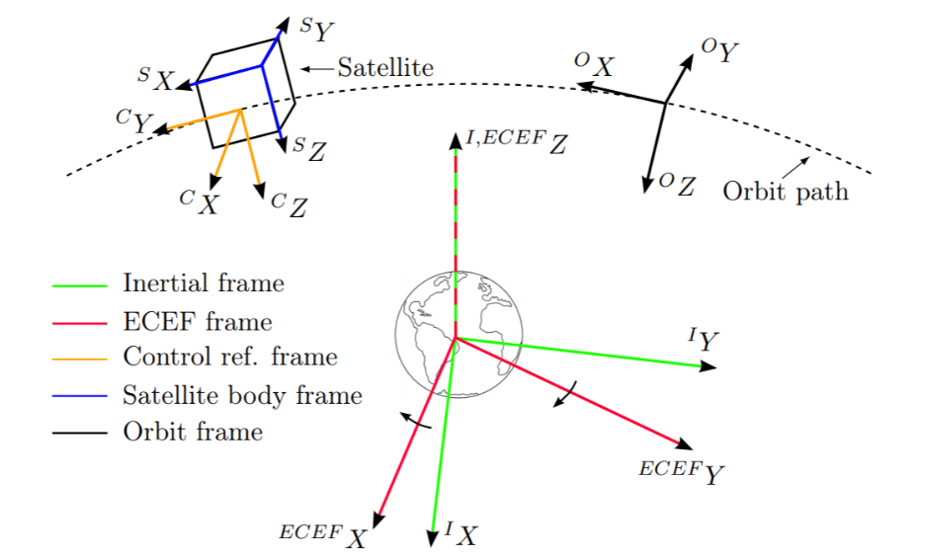It is critical that a standard set of reference frames are defined to provide a basis for the orientation of the CubeSat. These frames will be used to model the dynamics, disturbance torques, and control torques of the CubeSat. All coordinate frames defined below are right-hand orthogonal and are based on the standard established by Wertz [3]. The reference frames are as follows: *Orbital Frame (O)*, *Inertial Frame (I)*, *Earth-Centred Earth Fixed Frame (ECEF)*, *Satellite Body Frame (S),* and *Control Reference Frame (C)*. Refer to Figure 1 for a summary of all reference frames [4].

Figure 1 - Diagram of standard coordinate systems used to describe satellite orientation

### Dynamic Equation of Motion

The dynamic equation of motion developed in this section describes how torques relate to the CubeSat’s angular velocity and has been derived from the work of Wertz [3]. The dynamic equation is established in this section with the sources and values of torque explored in Design Validation. Establishing a dynamic equation of motion is not only essential to developing control law, but also in designing the actuators for the CubeSat.

Figure 2 - **R:** vector from inertial frame to CoM of CubeSat, $ρ_{i}$: vector from CoM to given mass i



*i*

O

**R**

$$ρ_{i}$$

Consider the rigid body in Figure 2, with *n­*-mass points. Using Newton’s second law, the angular momentum of the CubeSat in the *I* frame is:

$$\begin{aligned}L=\sum_{i=1}^{n}{m_{i}ρ_{i}×\frac{dρ_{i}}{dt}} \\ \#\left(2.1.1\right)\end{aligned}$$

The subscripts 1, 2, 3 will be used for components along a fixed axis within the CubeSat. All the time derivatives are to be given in the *I* frame for Newton’s laws of motion to apply. The time derivate of $ρ_{i}$ is seen below, where $ω$ is the angular velocity vector.

$$\begin{aligned}\frac{dρ_{i}}{dt}=ω×ρ_{i}\#\left(2.1.2\right)\end{aligned}$$

Equation 2.1.1 then becomes:

$$\begin{aligned}L=\sum_{i=1}^{n}{m_{i}ρ_{i}×\left(ω×ρ_{i}\right)}\#\left(2.1.3\right)\end{aligned}$$

Introducing the moment of inertia, ***I****,* its components are:

$$\begin{aligned}I_{11}≡\sum_{i=1}^{n}{m_{i}({ρ_{i2}}^{2}+{ρ_{i3}}^{2})}\#\left(2.1.4a\right)\end{aligned}$$

$$\begin{aligned}I_{22}≡\sum_{i=1}^{n}{m_{i}({ρ_{i3}}^{2}+{ρ_{i1}}^{2})} \#\left(2.1.4b\right)\end{aligned}$$

$$\begin{aligned}I_{33}≡\sum_{i=1}^{n}{m_{i}({ρ_{i1}}^{2}+{ρ_{i2}}^{2})} \#\left(2.1.4c\right)\end{aligned}$$

$$\begin{aligned}I_{12}=I_{21}≡-\sum_{i=1}^{n}{m_{i}ρ_{i1}ρ_{i2}}\#\left(2.1.4d\right)\end{aligned}$$

$$\begin{aligned}I_{23}=I_{32}≡-\sum_{i=1}^{n}{m_{i}ρ_{i2}ρ_{i3}}\#\left(2.1.4e\right)\end{aligned}$$

$$\begin{aligned}I_{31}=I_{13}≡-\sum_{i=1}^{n}{m_{i}ρ_{i3}ρ_{i1}}\#\left(2.1.4f\right)\end{aligned}$$

Equation 2.1.3 can then be rewritten in matrix form, utilizing the matrix of inertias.

$$\begin{aligned}L=I ω\#\left(2.1.5\right)\end{aligned}$$

The principal axes are the axes along which the principal moments of inertia lie. By letting the principal axes form the *C* frame, the off-diagonal elements of the inertia matrix disappear.

$$\begin{aligned}I_{C}=\left[\begin{matrix}\begin{matrix}I_{11} \\ 0\end{matrix} & \begin{matrix}\begin{matrix}0 & 0\end{matrix} \\ \begin{matrix}I_{22} & 0\end{matrix}\end{matrix} \\ 0 & \begin{matrix}0 & I_{33}\end{matrix}\end{matrix}\right]\#\left(2.1.6\right)\end{aligned}$$

The fundamental equation of attitude dynamics relates the time derivative of angular momentum to the applied torque, $N$. This is developed using Equation 2.1.6 and ${}_{I}^{C}ω$**,** the angular velocity relative to the *I* frame, given in *C*.

$$\begin{aligned}\frac{dL}{dt}≡\dot{L}=-{}_{I}^{C}ω ×L+N=I_{C}\dot{{}_{I}^{C}ω}\#\left(2.1.7\right)\end{aligned}$$

Equation 2.1.5 can be rearranged to form $ω={I }^{-1}L$. Substituting this into Equation 2.1.7 yields:

$$\begin{aligned}\dot{L}=-\left({I_{C} }^{-1}L\right)×L+N\#\left(2.1.8\right)\end{aligned}$$

Rearranging Equation 2.1.8 and substituting in Equation 2.1.5, yields the following.

$$\begin{aligned}\dot{L}=I_{C}\dot{{}_{I}^{C}ω}=-\left({I_{C} }^{-1}L\right)×L+N\#\left(2.1.9\right)\end{aligned}$$

$$\begin{aligned} I_{C}\dot{{}_{I}^{C}ω}=- {}_{I}^{C}ω×\left(I_{C}{}_{I}^{C}ω\right)+N\#\left(2.1.10\right)\end{aligned}$$

$$\begin{aligned}\dot{{}_{I}^{C}ω}=-{I_{C}}^{-1}[ {}_{I}^{C}ω×\left(I_{C} {}_{I}^{C}ω\right)]+{I_{C}}^{-1}N\#\left(2.1.11\right)\end{aligned}$$

Equation 2.1.11 is the dynamic equation of motion for the CubeSat. This will be used extensively in the development of control law in the future. $N$, the sum external torques caused by disturbances and control torques (magnetorquers), will be of concern in this report. The determination of disturbance torque values and comparison to the control torque for the designed magnetorquers can be found in Design Validation.

ADCS mathematics has proven to be a key challenge in recent weeks. Significant layers of additional mathematics underly ADCS, little of which has been introduced in undergraduate courses. Although significant time has been dedicated to understanding quaternions, satellite kinematics, dynamics, and orbital mechanics, the mathematics remain a weakness of the team. This is being addressed by designating two group members as responsible for continuing to read and practice the required mathematics.

## Actuator Selection

As stated in the introduction, it has been determined that magnetorquers are the ideal actuators for the Ukpik-1. The three types of magnetorquers are embedded, air-core and solid-core. Air-core magnetorquers are simply solenoids which are a long coil of wire wrapped uniformly into a cylindrical or cuboid shape that creates a magnetic dipole moment $(\overset{⃑}{D)}$ when current passes through the wire. Since this configuration is comprised solely of conductive wire, the overall mass, size and power consumption is relatively low. However, the produced $\overset{⃑}{D}$ is solely a function of the current, cross-sectional area and number of turns of the wire as shown in Equation 2.2.1 [5].

$$\begin{aligned}\overset{⃑}{D}=Ni\overset{⃑}{A}\#\left(2.2.1\right)\end{aligned}$$

Embedded magnetorquers are made through integrating a copper trace in the form of a quadrilateral into a printed circuit board (PCB). This category of magnetorquers requires the least amount of mass, power and space but as a result, produces the lowest $\overset{⃑}{D}$ of the different types [5]. Solid-core magnetorquers, also known as torquerod magnetorquers, are air-core magnetorquers wrapped around a solid material. This material is generally ferromagnetic because it will amplify the generated $\overset{⃑}{D}$ without the need to increase the current, cross-sectional area or number of loops [5]. However, this comes at the cost of an increased overall mass.

Although approximately 30% of all small satellites employ magnetorquers as a type of actuation [6], there is an extremely low number of commercially available options. The limited options and lack of customizability prevents the consumer from designing their small satellite in a way that best suits their desired functionality. A few examples of commercially available magnetorquers include the SatBus MTQ, MTQ200 and NCTR-M002. All three of these models only produce a $\overset{⃑}{D}$ magnitude of 0.2Am2 [7][8]. Additionally, they are often sizeable, for example, MTQ200 series magnetorquers by Hyperion Technologies have quite large dimensions of 10.7 x 80 mm (Ø x L) for their standard model [8]. These large, low power torquerods are also expensive: for example, the NCTR-M002 torquerod by NewSpace Systems costs a staggering $1,200 per rod [7]. Many small satellite projects, the Ukpik-1 included, are low-budget operations associated with academic institutions for educational purposes, and as such it is not logical to purchase commercial magnetorquers.

Instead, it is logical for the team to make its own magnetorquers. The main barrier to overcome is correctly manufacturing them with commercially available components. An appropriate amount of time will have to be dedicated to researching suppliers and their available products and iterating the overall magnetorquer design to best fit the Ukpik-1 requirements.

## Actuator Manufacturing

The physics governing electrical coils are dependent on the number of turns in the coil, the length of wire used and the fill factor of the coil layers. The fill factor of an electrical coil is a ratio between the cross-sectional area of the wires to the entire cross-sectional area of the test piece [9]. A high fill factor implies that the coiled wires are densely packed together, increasing electrical efficiency by reducing the variability of wire resistance [10]. The three main types of coil windings include wild, layered and orthocyclic windings. Wild windings follow no specific pattern and have the lowest fill factor of less than 75%. Layered windings place subsequent layers directly on top of each other and have an approximate fill factor of 78.5% [11]. Orthocyclic winding is the optimal method for winding circular wires, where sequential layers of wire sit in the grooves of the previous layers. The most precise forms of orthocyclic winding achieve the highest possible fill factor for circular wires of 90.7% but it is extremely difficult and expensive to manufacture correctly [12].

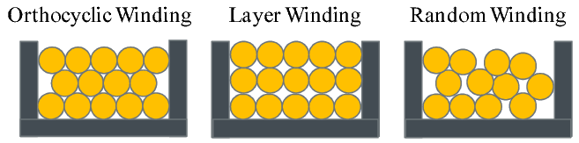

Figure 3 - cross sectional view of winding types

Another consideration associated with the fill factor is the deformation of the wire material. Smaller wires tend to have microscopic deformation that can decrease the fill factor of the coil. This effect can be mitigated by holding the wire under sufficient tension before winding, straightening it and reducing air gaps. Table 1 outlines the tension limits for various small gauge wires [13].

Table 1 - Tension Limits for a Range of Wire Gauges

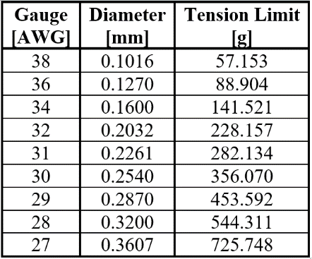

Current coil winding machines vary in the types of coils constructed, precision capabilities, size constraints, efficiency and levels of autonomy. The large variation in existing coil winding machines establishes a gap in current technologies, which is to develop a coil winding machine designed specifically for low budget magnetorquer manufacturing. Existing coil winding machines are capable of very high precision, high speeds, autonomous operation and vast customizability, but are often expensive to purchase or operate. Designing a magnetorquer specific coil winding machine allows for the cost and complexity of the machine to be drastically reduced. Unnecessary functionality of existing winders can be removed, and the size can be reduced to manufacture magnetorquers with a specific range of rod lengths and wire gauges.

# Scope, Constraints & Objectives

## Scope

The scope of this project can be broken into four specific areas. First, a type of actuator for the ADCS system must be selected, from which a detailed design must be produced. Second, a manufacturing and assembly process must be developed for the selected actuator. Third, a test environment must be designed to verify the actuators and the overall ADCS fulfill the desired objectives within the constraints of the project. In parallel with the testing phase, control law must be designed. Testing must verify the control law produces the desired actuator response with inputs from the set of available sensors.

As stated in the introduction, the focus of this report will be around the design of the actuator and the manufacturing apparatus for the actuator. This decision was made as it was deemed necessary to first have the actuators in order to properly design and test the overall ADCS. The design of the magnetorquer manufacturing apparatus also forms its own sub-project and will require its own iterative design approach in addition to the testing platform.

Once the actuators are successfully manufactured and characteristics determined, the control law will be developed such that the actuators produce the appropriate output based on functional mode and inputs from the sensors. Members of the CubeSat team and previous capstone team have developed some components of the control system which may be incorporated. Modifications are necessary as the actuators and sensors have recently changed, but potential system pitfalls and required theory to incorporate has been identified.

The team's future work will include purchasing materials, building and testing of the actuators and manufacturing apparatus. It will also involve developing a control law that accurately incorporates the produced actuators and sensors. Finally, each component will have to be evaluated through individual unit tests followed by an overall system test which will simulate the space environment the CubeSat is intended for.

## Objectives and Constraints

### Magnetorquer



Table 2 - Magnetorquer Design Objectives



Table 3 – Magnetorquer Design Constraints

### Magnetorquer Manufacturing

Table 4 - Magnetorquer Manufacturing Apparatus Design Objectives

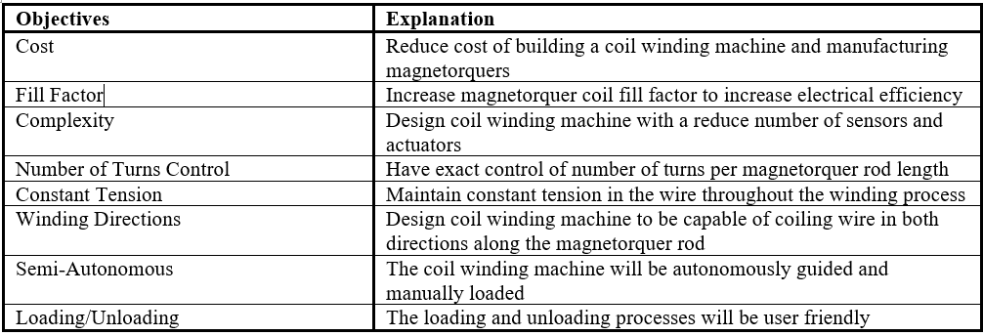

Table 5 - Magnetorquer Manufacturing Apparatus Design Constraints

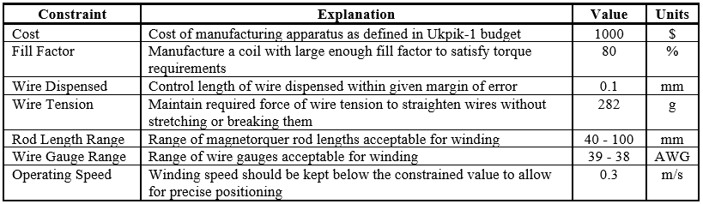

# Concept Generation & Selection

## Magnetorquer Design

The first step in designing the magnetorquers for Ukpik-1 involved determining which type to use. There exists three types of magnetorquers: embedded, air-core and solid-core. Each of these were compared against one another with the use of a decision matrix. The decision matrix in Table 6 identified solid-core magnetorquers as the best option. The true competition was between air-core and solid-core magnetorquers. What set the solid-core apart was its ability to produce a $\overset{⃑}{D}$ while requiring less power and volume. Although it brings non-linearities into the design, the benefits outweigh this complexity.



Table 6 - Magnetorquer Type Decision Matrix

Once the solid-core magnetorquers were determined to be the optimal type, the next steps were to determine which materials should be used to construct them. Regarding the type of wire, there are two options that have set themselves apart for use in magnetic circuits: aluminum and copper [14]. Since copper is the most common conductor used, virtually every supplier associated with electrical application carries it. This allows its prices to be lower than aluminum wire which is sometimes favoured to minimize mass. The decision matrix comparing these two options is shown below in Table 7 with copper wire proving to be the optimal option.



Table 7 - Wire Material Decision Matrix

It is a well-known fact that current passing through a conductive wire induces a magnetic field in the surrounding space. The strength of this field and associated $\overset{⃑}{D}$ can be altered due to the permeability of the surrounding medium [15]. Magnetization is the value that quantizes the density of magnetic dipole moments in magnetic materials [5]. Ferromagnetic materials present the strongest magnetization of any magnetizable material as depicted in the magnetization curve in Figure 4 [16].

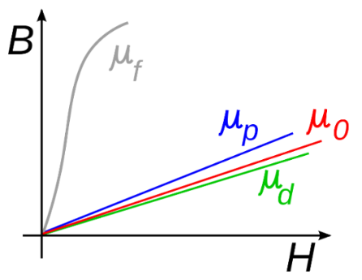

Figure 4 – Effect of Permeability on Magnetization

*µf – ferromagnets, µp – paramagnets*

*µ0 – free space, µd - diamagnets*

An important note in Figure 4 is that although ferromagnetic materials produce the greatest magnetic field from the lowest inducing field intensity, this relationship is nonlinear and follows a hysteresis curve as shown in Figure 5.

Figure 5 – Hysteresis of Ferromagnets

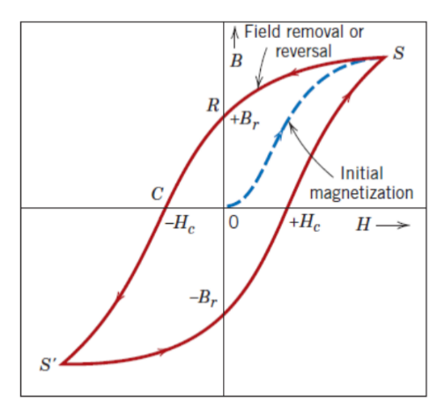

Hysteresis brings the issue of having more than one value of magnetic field/magnetic dipole moment from the same inducing field intensity. This could pose an issue with controlling the actuation system. The material property that helps to reduce the effects of hysteresis is its permeability. The higher the permeability of the material, the less resistance it has to change its magnetic state [5]. Materials with high permeability are considered soft magnetic materials whereas the opposite are considered hard magnetic materials [17]. To summarize, the more permeable a material is, the more linear its magnetization response is. This is shown in Figure 6.

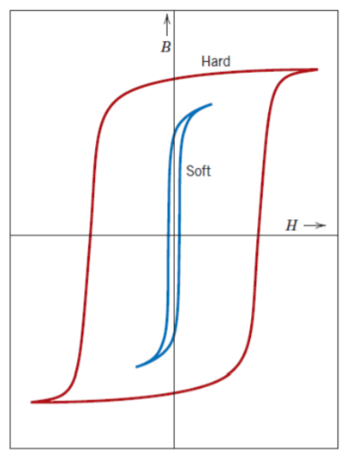

Figure 6 – Hysteresis of Hard and Soft Ferromagnets

It is quite apparent that highly permeable material is vital for producing a significant $\overset{⃑}{D}$ as well as having the magnetorquer respond as linearly as possible. Three soft ferromagnetic materials were identified, each an alloy containing nickel, iron or cobalt, and compared against one another in the decision matrix shown in Table 8. It was concluded that 78.5Ni-Fe, soft, was the best material to be used for the core. Although it wasn’t the lightest, its relatively modest price of 14.3-16 CAD/kg [18] and highest permeability made it the optimal option.



Table 8 - Core Material Decision Matrix

With the type of magnetorquer and material of the components chosen, the final step was determining the parameters of each component such that the magnetorquer satisfied the objectives/constraints. There were many variables that had to be considered in order to meet the design constraints. An optimization process was employed to determine parameters for the magnetorquers, which will be discussed in detail in the Design Validation section. The results obtained from this optimization process and model of the resulting magnetorquer are shown in Table 9and Figures 7-9.

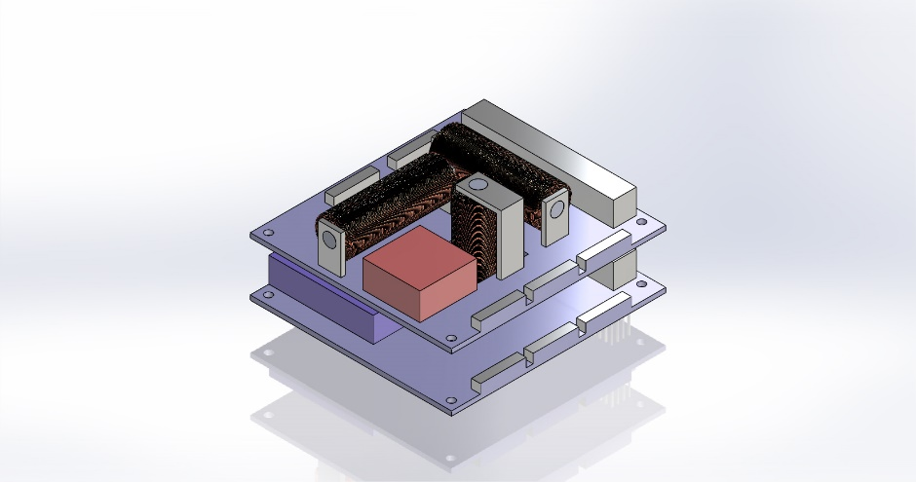

Figure 7 - Magnetorquers mounted on Custom PCBs

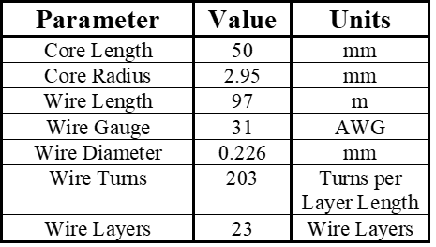

Table 9 - Final Magnetorquer Parameters

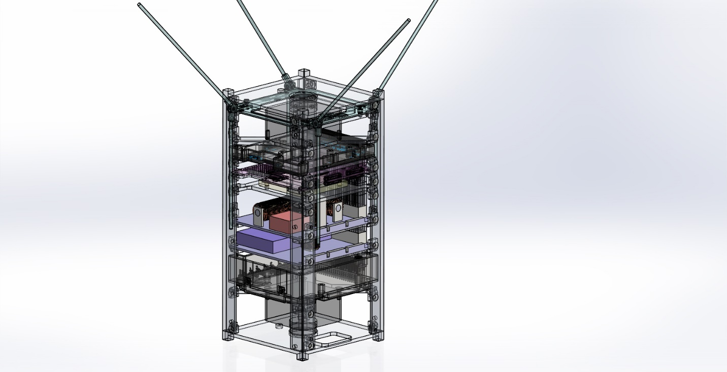

Figure 8 - Location of Magnetorquers in Ukpik-1

Figure 9 - Final Magnetorquer Design

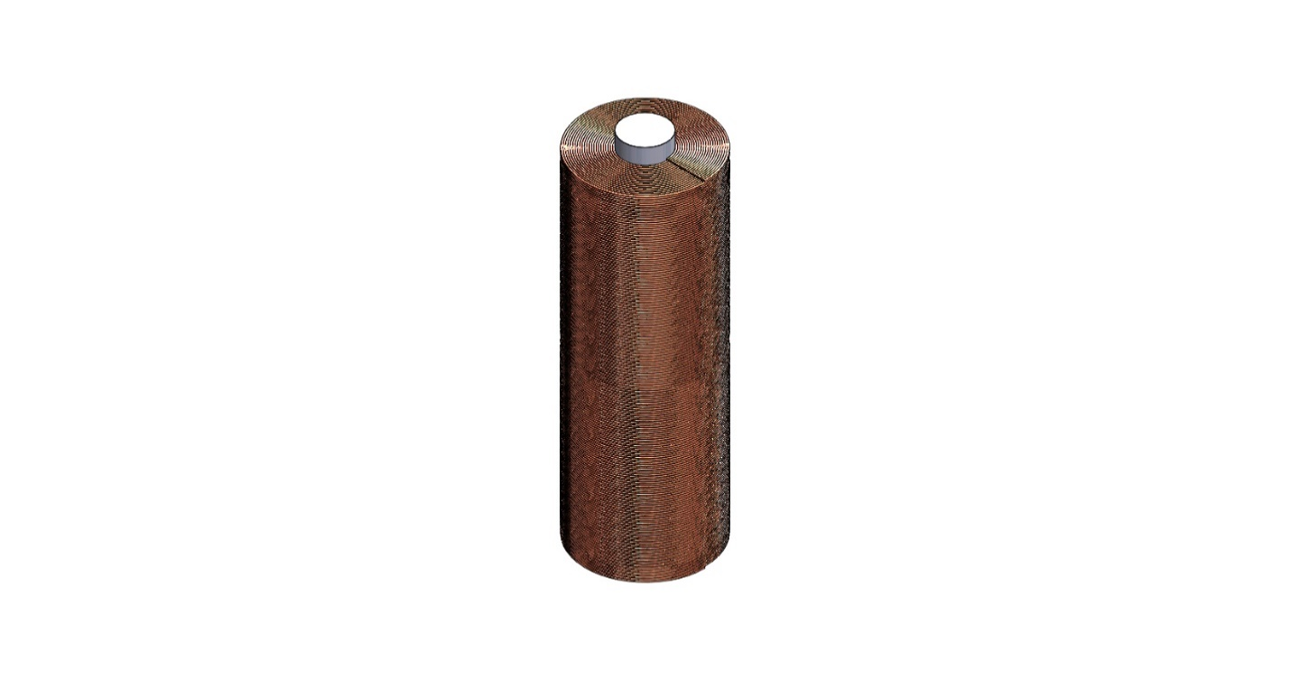

## Magnetorquer Manufacturing Apparatus Design

Concept generation will focus on developing a coil winding machine designed specifically for magnetorquer manufacturing. Unlike most existing coil winding machines, there is no time constraint for manufacturing each coil and the winder can operate at a slower speed to achieve precise wire placement. The objective of having a semi-autonomous system allows the machine to be designed for manual loading and unloading. After considering these two specifications for the magnetorquer winding machine, concepts could be generated to satisfy the remaining objectives and constraints.

To generate concepts for the magnetorquer winding machine the process was divided into two individual subsystems. These include the wire tensioning and guidance systems.

As explained in the background information section, continuous tension in the wire is required to minimize air gaps within the coil. The concepts generated for increasing tension in the wire include a tension rod, spool mounted with viscous bearings and a servo-controlled spool. The tension rod concept involves an additional rotating shaft positioned parallel to the spool of wire. As the wire comes off the spool, it wraps around the tension rod resulting in more force being required to pull the wire off the spool. The viscous bearing mounted spool is a simple concept in which the friction generated in the viscous bearing restricts the rotation of the spool. A servo-controlled spool of wire could accurately control the magnitude of wire tension by rotating the spool in the opposite direction as the dispensed wire. Table 10 is the tensioning system decision matrix and demonstrates that the tension rod is the optimal solution for a magnetorquer winding application. A CAD model of the selected concept is presented in Figure 10.

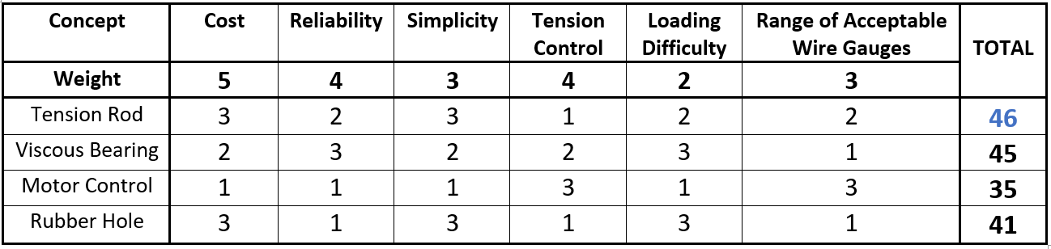

Table - Manufacturing Apparatus Tensioning System Decision Matrix

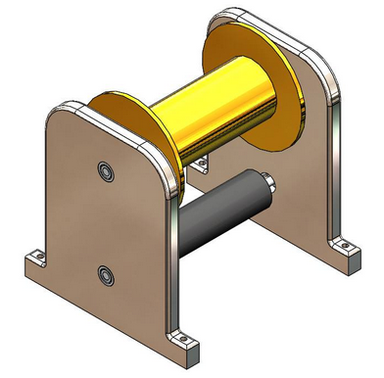

Figure 10 - CAD Model of Tension Rod Concept

The next step was to generate concepts for guiding the wire onto the magnetorquer core. The concept objective is to rotate the magnetorquer core to pull wire onto it, and then translate the wire horizontally in smalls increments to disperse it along the shaft. These concepts include a single and double stepper motor design, as well as an independent guidance system. The single stepper motor concept secures the magnetorquer core axially to a lead screw that is actuated by the stepper motor. The stepper motor allows for precise position control of the lead screw, which when rotated will translate and rotate the core simultaneously. The double stepper motor design utilizes one motor to control translation through a rack and pinion setup, then uses the additional motor to control the core rotation. Introducing an additional stepper motor increases the cost and complexity of the design but would provide substantially more control over the wire positioning and the winding direction. The final concept generated separates the guidance system into two individual components. One component mounts the magnetorquer core axially to a servo motor shaft that rotates at a constant velocity. The other component is a horizontal pulley mounted to a servo-controlled lead screw that is positioned in between the wire spool and the magnetorquer core. As the core rotates and coils wire around itself, the wire is guided along the shaft by actuating the lead screw in small increments. This concept would achieve the highest level of precision because separating the translational and rotational aspects of the system allows for each to be controlled independently. The decision matrix for selecting a guidance concept is shown in Table 11 and concludes that an independent guidance system is an optimal solution. An independent guidance system satisfies most of the requirements, with the only downside being increased cost. The other concepts lacked sufficient reliability, guidance control and variability, resulting in substantially lower scores.

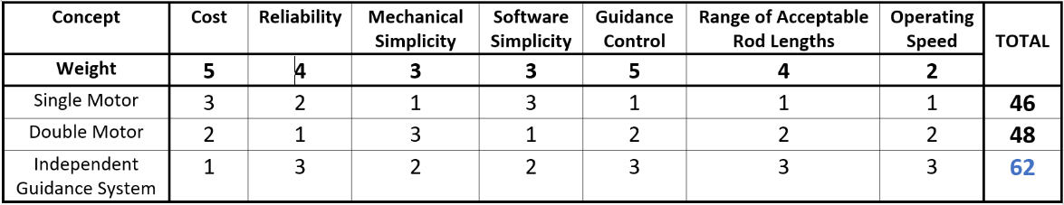

Table 11 - Manufacturing Apparatus Guidance System Decision Matrix

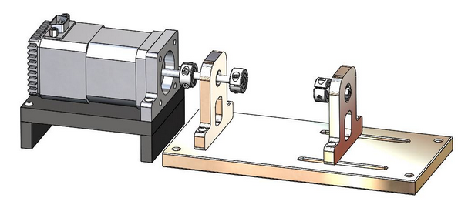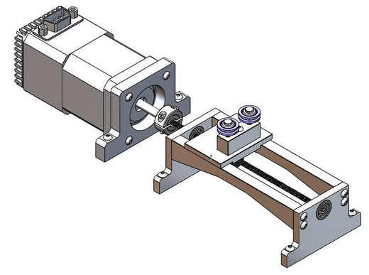

Figure 11 - CAD Model of Independent Guidance System Concept

The selected concepts represent a preliminary design for the subsystems of a magnetorquer coil winding machine. Future iterations of the design will focus on refining each subsystem to work together and form a single magnetorquer manufacturing system. The process of iterating, prototyping and testing the system will be outlined in the design validation section of this report.

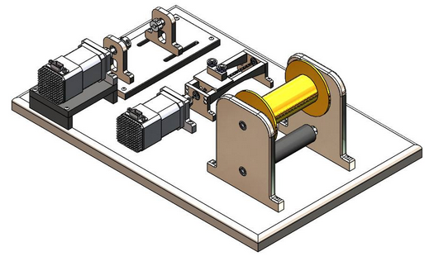

Figure 12 - Complete CAD Assembly of Magnetorquer Manufacturing Apparatus

# Design Validation

## Project Scoping and Planning

The first step taken in the project involved getting a clear understanding of the scope of the project as it related to the Ukpik-1 project. This involved meeting with Dr. Cross, the advisor of this project and the Project Manager for the Western/Nunavut CubeSat project. Next, extensive research was conducted on previous CubeSat and nanosatellite projects to gain an understanding of approaches to the design, development and testing of ADCSs that had proven effective in the past, and to identify gaps in existing technologies and manufacturing techniques.

In parallel with understanding the scope, planning was conducted. This involved developing an initial budget for time and financial resources as well as establishing rules of engagement with other members of the team and the project advisor. Further, the team established methods and tools (Trello, single shared drive, regular meetings, methods of online communication) to stay organized and on the same page of a schedule constantly subject to change. This initial clarification of scope and planning has allowed for subsequent design steps to flow smoothly.

## 5.2 Magnetorquer Design

As stated in the concept selection, there were multiple variables that needed to be determined to successfully complete the magnetorquer design. An optimization process was employed using the MATLAB code in Appendix 1. The first step in this process was identifying the constraints and material parameters already set in place and the variables which needed to be determined. The length of the core and wire diameter were deemed to be independent variables that were varied based on commercially available products. This is summarized in Tables 12-15.



Table 13 - Considered Core Lengths



Table 12 - Constraints



Table 15 - Parameters to be Determined



Table 14 - Considered Wire Diameters

Optimized wire length, diameter, number of turns and number of layers were calculated directly from the constraints on mass, power and volume allowed. These values were then assigned to each possible core length to solve for the resulting core diameter. The configuration which produced the greatest magnetic dipole moment was chosen.

The length of the wire for each gauge considered was calculated as a function of the supply voltage, supply power, resistivity of copper and the wire radius through the employment of Equation 5.2.1 which was derived from first principle electric relations shown in Equation 5.2.2 [19].

$$\begin{aligned}l_{w}=\frac{V^{2}π{r_{w}}^{2}}{PW_{res}}\#\left(5.2.1\right)\end{aligned}$$

$$\begin{aligned}R=\frac{V^{2}}{P} R=\frac{W_{res}l}{A}\#\left(5.2.2\right)\end{aligned}$$

Possible core radii were then determined based on the magnetorquers mass constraint. They were calculated as a function of the considered wire radii and core lengths, calculated wire lengths and density of the materials used. This relation is shown in Equation 5.2.3. All core radii that result in a diameter greater than the constrained height/width was eliminated from contention [19].

$$M=π{r_{c}}^{2}l_{c}ρ_{c}+π{r_{w}}^{2}l_{w}ρ_{w} \\ \begin{aligned}r_{c}=\sqrt{\frac{M-π{r_{w}}^{2}l_{w}ρ_{w}}{πl_{c}ρ_{c}}}\#\left(5.2.3\right)\end{aligned}$$

The number of turns and layers of the wire were the next parameters determined. The number of turns refers to how many times the wire is turned around the core along the specified length, Lb, as shown in Figure 13. Note that Ls indicates the width of the PCB supports in which the magnetorquers are secured to and have been deemed a value of 2 mm. The number of layers refers to how many times the wire is consecutively stacked on top of itself, as shown in Figure 14.

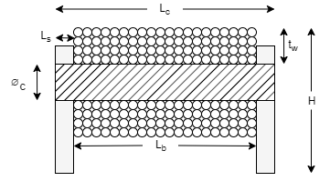

Figure 13 - Magnetorquer Coil Cross Section

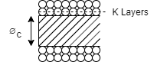

Figure 14 - Magnetorquer Wire Layers

The number of turns for each possible configuration was calculated through the employment of Equation 5.2.4 [20].

$$\begin{aligned}N=\frac{L_{b}}{2r_{w}}\#\left(5.2.4\right)\end{aligned}$$

The required number of layers was determined through the iterative analysis involving the overall length of wire, core radius, number of turns per layer and wire radius. With the number of required layers determined, each configuration of core length, radius, wire gauge and length were analyzed to see if it met the size constraints. This was done by calculating the allowable number of layers by considering the different wire and core radii and the constrained height/width. Equation 5.2.5 depicts this relation [20].

$$\begin{aligned}K_{all}=\frac{h-2r_{c}}{4r_{w}}\#\left(5.2.5\right)\end{aligned}$$

Calculated configurations of core lengths and radii and types of wire were eliminated from consideration if their number of required layers was greater than what was allowed. Remaining configurations which involved a core length of 10 and 15 mm were eliminated due to the result shown in Figure 15.

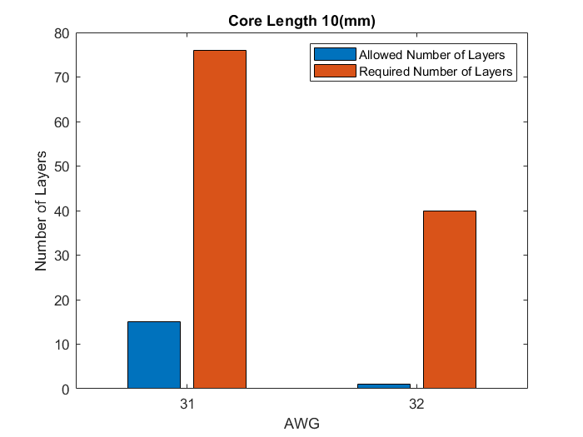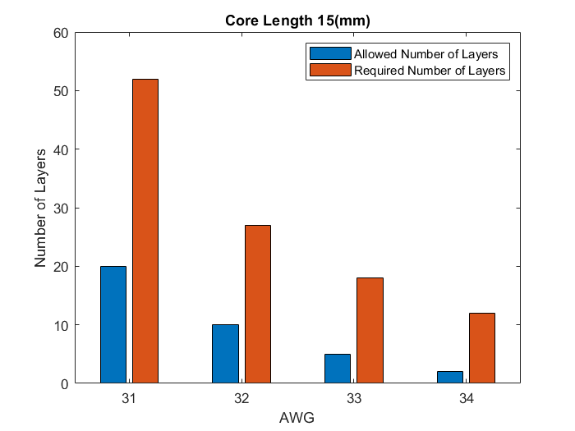

Figure 15 – Allowed Number of Layers versus Required Number of Layers

The final step in determining the optimal parameters for the magnetorquers was to compare each of the remaining configurations that met the constraints in terms of the magnetic dipole moment they could produce. This was done by first calculating the demagnetizing factor (Nd) for each configuration. The magnetization of a material is affected by its Nd which takes its physical size into consideration. Equation 5.2.6 defines this relation [21].

$$\begin{aligned}N_{d}=\frac{4\left[\ln\left(\frac{l_{c}}{r_{c}}\right)-1\right]}{{\left(\frac{l_{c}}{r_{c}}\right)}^{2}-4\ln\left(\frac{l_{c}}{r_{c}}\right)}\#\left(5.2.6\right)\end{aligned}$$

The magnetic dipole moment of each configuration was then calculated through Equation 5.2.7 [21].

$$\begin{aligned}D=\frac{r_{c}Vπ{r_{w}}^{2}}{2W_{res} }\left[1+\frac{µ_{c}-1}{1+\left(µ_{c}-1\right)N_{d}}\right]\#\left(5.2.7\right)\end{aligned}$$

The calculated magnetic dipole moment was then plotted against the core radius and size to determine which configuration maximized it. As shown in Figure 16, the configuration which has a core length of 0.05 m and a core radius of 0.002949 m produces the highest magnetic dipole moment of 0.6655 A/m2; three times more than the commercially available magnetorquers. This configuration utilizes 31 AWG wire size constraints as shown in Figure 17.

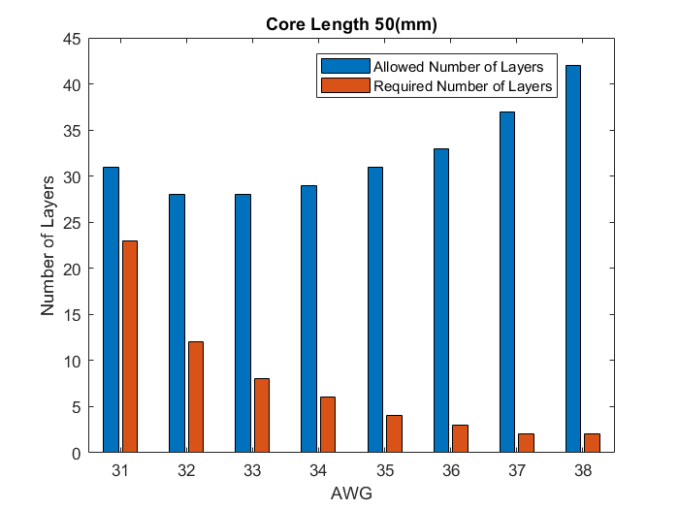

Figure 17 - Allowable and Required number of Layers

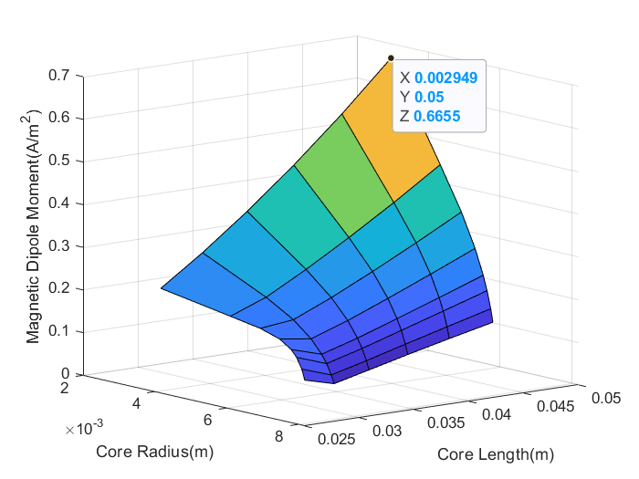

Figure 16 - Magnetic Dipole Moment Vs. Core Length vs. Core radius

Once these magnetorquers are manufactured, they will require testing to determine two important quantities: the actual produced magnetic dipole moment and time constant. The true magnetic dipole moments the magnetorquers can produce will have to be determined in order to use them effectively. A testing strategy could follow a similar approach Djilali Amrani employed by measuring the magnetic force at difference known distance and then linearization the relation [22]. Since the solenoids can be classified as inductors, the magnetorquers will have to be appropriately modelled within the control system. Determining their time constants should not be a rigorous task as the group has completed this task for simple RL circuits in the past. It will only require access to an oscilloscope and power supply. This testing process has not been finalized, being deemed as a future task for the group to accomplish.

## 5.3 Torque Validation

### 5.3.1 Disturbance Torques

Disturbance torques are external torques that the actuators must overcome to effectively orient the CubeSat.

*Gravity Gradient Torque*

Gravity gradient torque is caused by variation in the gravitational field caused by Earth. From the work of Holst, the torque exerted on the CubeSat due to the gravity gradient, $N_{g},$ is determined to be the following [4].

$$\begin{aligned}N_{g}=3{ω_{O}}^{2}\left({}_{}^{C}{k_{O}}×I_{C}{}_{}^{C}{k_{O}}\right)\#\left(5.3.1\right)\end{aligned}$$

$ω_{O}$ is the orbital angular velocity, ${}_{}^{S}{k_{O}}$ is the third column in the rotation matrix relating the *O* frame to the *C* frame, and $I_{C}$ is the inertia matrix in the *C* frame, as defined in Equation 2.1.6.

$ω_{O}$ is defined below, where *µ* is the Earth’s gravitation parameter and $a$ is the CubeSat’s position relative to Earth’s center [4].

$$\begin{aligned}ω_{O}=\sqrt{\frac{μ}{a^{3}}}\#\left(5.3.2\right)\end{aligned}$$

The largest value for $N_{g}$ is the worst-case scenario, and results when the CoM is displaced from the volumetric center by the maximum value. The CubeSat leadership team constrained the CoM of the satellite to be no more than 2cm from the volumetric center.

Figure 18 - CoM displacement resulting in maximum gravity gradient

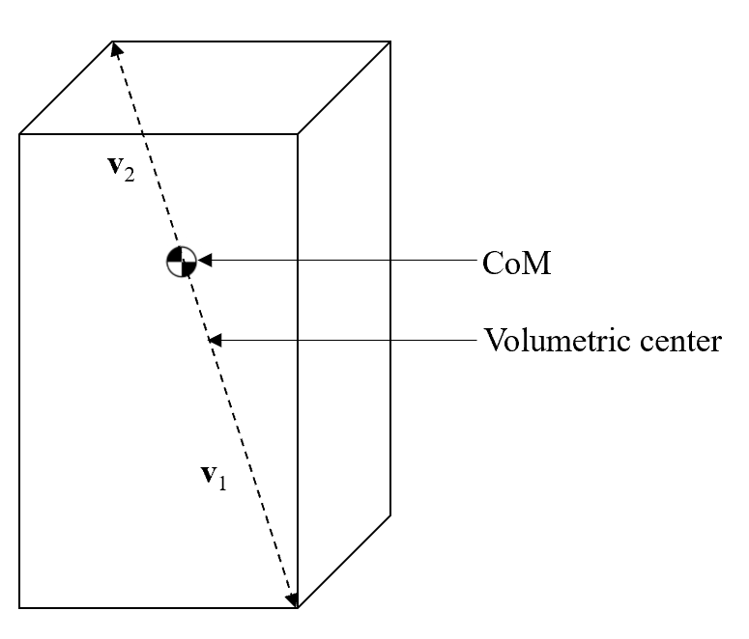

*m*1

*m*2

The shift of the CoM by 2cm along the diagonal in Figure 18 represents the worst case for , with **v**1 and **v**2 representing vectors from the CoM to the corners, with *m*1 and *m*2 being the respective masses in these directions. With set dimensions of 10cm x 10cm x 21.7cm, **v**1 and **v**2 are:

Using an overall mass of 2.997kg, *m*1 and *m*2 are calculated to be:

$$\begin{aligned}m_{1}=1.730kg\#\left(5.3.4\right)\end{aligned}$$

$$\begin{aligned}m_{2}=1.267kg\#\left(5.3.5\right)\end{aligned}$$

Through determining ***I*** using Equation 2.1.4(*a-f*)*,* the maximum $N_{g}$ is calculated to be 34.23nNm.

*Aerodynamic Drag*

Since the CubeSat will be in low earth orbit, it will experience aerodynamic drag, a resisting force caused by the surrounding atmosphere. The torque from atmosphere drag $N_{aero }$ is at a maximum when the exposed surface area is at a maximum and the vector from the center of pressure to the CoM is perpendicular to the CubeSat velocity vector.

The aerodynamic drag force can be calculated as [4]:

$$\begin{aligned}F_{aero}=-\frac{1}{2}C_{D}ρ_{600}v^{2}\left(\hat{N}∙\hat{v}\right)\hat{v}dA\#\left(5.3.6\right)\end{aligned}\begin{aligned}F_{aero}=-\frac{1}{2}C_{D}ρ_{600}v^{2}\left(\hat{N}∙\hat{v}\right)\hat{v}dA\#\left(5.3.5\right)\end{aligned}$$

The variables are defined as [4]:

* $C_{D}$: drag coefficient=2
* $ρ_{600}$: air density at 600km altitude=1.454*10-13kg/m3
* : velocity, estimated maximum=6000m/s
* $\left(\hat{N}∙\hat{v}\right)\hat{v}$**: the** angle between the normal vector and the exposed area
* *d*A: exposed area=0.01733m2

The resulting torque is calculated as follows, where $R_{CoM}$ is the vector from the CoM to the geometric center of pressure.

$$\begin{aligned}N_{aero }=F_{aero}×R_{CoM}\#\left(5.3.7\right)\end{aligned}\begin{aligned}N_{aero }=F_{aero}×R_{CoM}\#\left(5.3.6\right)\end{aligned}$$

Since CubeSats are standard dimensions, and aerodynamic drag is not dependent on the unique mass of Ukpik-1, the $N_{aero }$ can be taken from previous CubeSat projects also released from the ISS. Therefore $N_{aero }$ is determined to be a maximum of 22.54nNm [4].

*Solar Radiation*

Photons, mainly from the sun, will exert a force on the CubeSat. This results in a torque, $N_{rad }$,around the center of mass. The radiative force is [3]:

$$\begin{aligned}F_{rad}=C_{a}PA\#\left(5.3.8\right)\end{aligned}\begin{aligned}F_{rad}=C_{a}PA\#\left(5.3.7\right)\end{aligned}$$

$C_{a}$ is the absorption constant between 1 and 2, *P* is the solar flux and A is the radiated area. *P* is calculated as follows, where Fs is the mean solar energy equal to 1358 W/m2 and *c* is the speed of light.

$$\begin{aligned}P=\frac{F_{s}}{c}=4.53*{10}^{-6}kg/{ms}^{2}\#\left(5.3.9\right)\end{aligned}\begin{aligned}P=\frac{F_{s}}{c}=4.53*{10}^{-6}kg/{ms}^{2}\#\left(5.3.8\right)\end{aligned}$$

The torque due to solar pressure can then be calculated [3].

$$\begin{aligned}N_{rad }=F_{rad}×R_{CoM}\#\left(5.3.10\right)\end{aligned}\begin{aligned}N_{rad }=F_{rad}×R_{CoM}\#\left(5.3.9\right)\end{aligned}$$

With $R_{CoM}$ representing the vector from the CoM to the geometric center of radiation pressure, and by maximizing ${ F}_{rad}$ to represent the worst-case scenario, $N_{rad }$ is calculated to be 3.14nNm.

*Magnetic Residual Dipole*

The magnetic residual dipole refers to the magnetic dipole created by electric components and materials in the CubeSat.

The torque resulting from the magnetic residual dipole can be calculated as follows, where $m_{mag}$ is the magnetic moment of the CubeSat [3].

$$\begin{aligned}N_{mag }=m_{mag}×B\#\left(5.3.11\right)\end{aligned}\begin{aligned}N_{mag }=m_{mag}×B\#\left(5.3.10\right)\end{aligned}$$

$B$ is the magnetic flux vector from the Earth, the magnitude of which is calculated as follows [3].

$$\begin{aligned}B=\frac{2M}{r^{3}}\#\left(5.3.12\right)\end{aligned}\begin{aligned}B=\frac{2M}{r^{3}}\#\left(5.3.11\right)\end{aligned}$$

The above variables can be defined as follows [4].

* *M*: Earth’s magnetic moment = 7.96*1015T
* *r:* Distance from center of Earth to CubeSat = 6978km

It is challenging to determine the exact value of $m_{mag}$ without performing testing on the completed CubeSat, therefore, it will be estimated to be 10mAm2 based on work by NASA [23]. This results in $N_{mag }$ to be 468.54nNm.

*Summary of Disturbance Torques*

Table 16 - Summary of disturbance torques

|  |  |
| --- | --- |
| **Source** | **Torque (nNm)** |
| Gravity Gradient ($N_{g}$) | 34.23 |
| Aerodynamic Drag ($N_{aero}$) | 22.54 |
| Solar Radiation $(N_{rad }$) | 3.14 |
| Magnetic Residual Dipole ($N_{mag }$) | 468.54 |
| **Total Disturbance Torque ($N_{dist }$)** | **528.45** |

### 5.3.2 Control Torque

The control torque, $N_{ctrl}$, refers to the torque produced by the magnetorquers. This can be determined through the following equation, in frame *C*:

$$\begin{aligned}{{}_{}^{C}N}_{ctrl}={}_{}^{C}m×{}_{}^{C}B\#\left(5.3.13\right)\end{aligned}$$

$$\begin{aligned}{{}_{}^{C}N}_{ctrl}={}_{}^{C}m×{}_{O}^{C}A{}_{}^{O}B\#\left(5.3.14\right)\end{aligned}$$

Where ${}_{}^{C}m$ is the magnetic dipole moment in *C*, ${}_{O}^{C}A$ is the rotation matrix from *O* to *C*, and ${}_{}^{O}B$ is the magnetic flux vector of Earth, the magnitude of which is defined by Equation 5.3.12.

The magnitude of the maximum dipole moment was determined to be *m*=0.6655 A/m2. The resulting ${{}_{}^{C}N}_{ctrl}$ this dipole produces cannot yet be calculated since the orientation of the *C* frame is dependent upon the moments of inertia, which cannot be calculated until all subsystems (mass and position in CubeSat) have been solidified. However, comparing this dipole moment to previously launched CubeSats with magnetorquers, it is sufficiently large [4], [24].

## 5.4 Magnetorquer Manufacturing Apparatus Design

In order to validate the functionality of the magnetorquer manufacturing apparatus, it must be capable of producing a magnetorquer that generates a magnetic dipole close to the theoretically calculated value. As outlined in the background information section, the winding fill factor is an important parameter in producing an efficient coil. Equation 5.4.1 can be used to calculate a theoretical fill factor value based on the chosen magnetorquer parameters.

$$\begin{aligned}FF=\frac{\left.\left(πr_{w}^{2}\right)N\right.K}{\left[L_{b}\right]\left[2Kr_{w}\right]}=\frac{πr_{w}N}{2L_{b}}\#\left(5.4.1\right)\end{aligned}$$

A fill factor calculated this way represents the ideal fill factor of a layered coil winding. According to the parameters determined in the magnetorquer design section, the theoretical layered fill factor of the Ukpik-1 magnetorquers is 78.5%. A less than ideal orthocyclic (helical) winding is more easily achieved than an ideal winding, and still provides a substantially larger fill factor than a layered or wild winding. The constraint imposed on the magnetorquer manufacturing apparatus is to achieve a fill factor greater than 80%, which is achievable when considering the approximate fill factor of layered windings is 78.5%. To validate the functionality of the magnetorquer manufacturing apparatus, it should be able to produce a helical coil with a sufficient fill factor.

To design a magnetorquer winding machine concept generation was done for two individual subsystems each responsible for a different part of the manufacturing process. The next step is the detailed design process, in which the selected concepts are refined and fully specified to begin prototyping. Upon completing the first prototype the design can begin testing to validate its production of helical windings.

The first set of tests will isolate the tensioning system to test the generation of wire tension and how well the dispensed length of wire is controlled. Then the guidance system will be isolated to test its functionality by feeding wire directly from the spool by hand and monitoring the resulting coil winding. Once each subsystem functions correctly in isolation, they will be integrated together and tested as an entire system. At this point, a prototype magnetorquer will be manufactured and tested to validate the design of the magnetorquer coil winding machine. If the resulting magnetorquer is not electrically efficient enough, the winding machine design will be iterated upon until a satisfactory product is produced. Each design iteration and test will bridge gaps in knowledge required to design a valid magnetorquer manufacturing device.

## 5.5 System Testing and Control System Development

The current future testing plan is to create or acquire a Helmholtz cage to simulate the magnetic field of Low Earth Orbit. After the actuators are confirmed correctly manufactured, the ADCS can be tested as a whole system in the simulated field. Control System Development will occur in parallel with this testing, to ensure the control law obeys the real configuration of the system.

# Progress, Schedule & Planning

The project is still effectively on schedule to completion; however, some adjustments have been made to the schedule due to current progression. Most notably, it was decided that establishing a manufacturing plan and design should be the focus of this report, as opposed to testing. Tasks related to testing were moved to take place after this report, and some holiday and exam break time is to be used to focus on testing. There is further buffer time still available in the block solely dedicated to compiling the final report and presentation as a contingency plan for tasks behind schedule. The current schedule can be seen in Table 18, and it correlates to the legend found in Table 17.

Table 17 - Color Coding of Gantt Chart

|  |  |
| --- | --- |
|  | Deliverables |
|  | Research Tasks |
|  | Documentation / Project Management Tasks |
|  | Tasks directly focused on ADCS Design |
|  | Tasks directly focused on Testing Design |

Table 17 - Gantt Chart Describing Project Schedule

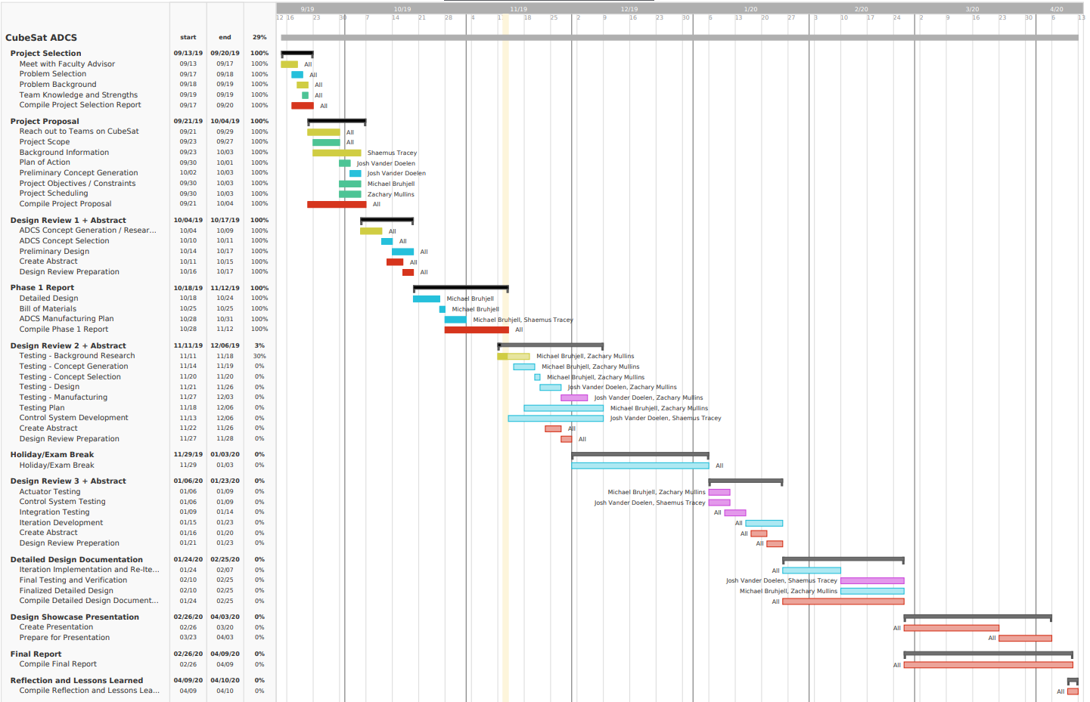

# Resources & Budget

In addition to our personal strengths between us of CAD, software development, control systems, and electrical manufacturing, we have access to external support from a wide variety of groups. The first of which is our project managers and advisors of the Western CubeSat project who provide support, leadership and knowledge: Dr. Matthew Cross, Dr. Kenneth McIsaac, and Dr. Jayshri Sabarinathan. The Western CubeSat project also has multiple capstone teams and graduate students working on it, providing a community of knowledgeable technical support.

The budgets for the guidance system in the wire tension system can be found in Table 19 and 20 respectively. All components and the respective prices were found on McMaster-Carr.com. Further budgeting will be required to manufacture the custom components required for the design. Table 21 shows the magnetorquer budget [25].

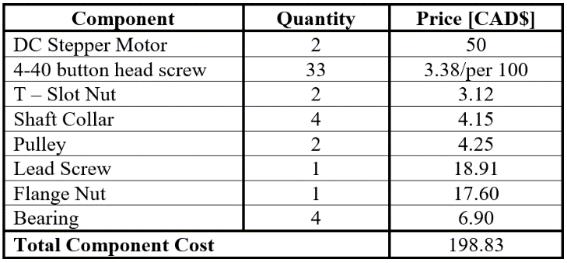

Table 19 - Guidance System Component Budget

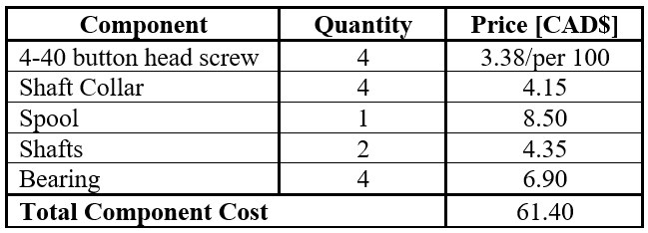

Table 20 - Wire tensioning system component budget

- Wire Tensioning System Component Budget

Table 21 - Magnetorquer Budget



# Conclusions & Recommendations

Overall, the team has made solid progress since Design Review I. The magnetorquer parameters, design and manufacturing process have been determined and are currently being reviewed by the CubeSat advisors. Once they receive approval, the components will be ordered, and manufacturing will begin. The main issues the team has encountered involved understanding attitude kinematics and dynamics and coordinating between the various CubeSat teams. The mathematical concepts required are quite advanced, included unfamiliar concepts such as quaternions. Additionally, since the CubeSat project is an interdisciplinary project, there are various teams working on different sub-projects. This has proven to cause some issues with respect to obtaining certain information such as battery parameters and PCB designs that play a role in the team's project.

Once the manufacturing process has been built, tested and the magnetorquers constructed, unit testing will commence to determine how they will be integrated into the ADCS system. The control law will then be developed. To overcome previous struggles and potential future ones, regular meetings between the team and advising council will continue to eliminate misinterpretation and lack of communication of information.

# Appendix

% Magnetorquer_Parameters script is intended to caclulate the free

% parameters to determine the optimal design.

% Set Constants

total_Mass = 0.140; % Mass of all Magnetorquers (Kg)

M = total_Mass/3; % Mass per Magnetorquer (Kg)

V = 5; % Supply voltage for ADCS (V)

P = 0.6; % Supply Power for ADCS (W)

Wres = 1.72e-8; % Resistivity of Copper Wire (ohm.m)

pc = 8590; % Density of 78.5Ni-Fe (Kg/m^3)

pw = 8960; % Density of Copper (Kg/m^3)

ur = 200000; % Permeability of Core (H/m)

% Wire Guages ranging from 31-38 AWG

rw = [0.226, 0.2, 0.18, 0.16, 0.142, 0.13, 0.114, 0.1];

rw = rw./2000; % Wire Radius in m

AWG = [31, 32, 33, 34, 35, 36, 37, 38];% Wire AWG gauge

% Core length ranging from 0.01-0.05m

lc = [0.01:0.005:0.05];

% POWER CONSTRAINT

% Calculate Length of Wire (m)

for i=1:length(rw)

lw(i) = ((V^2)*pi*(rw(i)^2))/(P*Wres);

end

% MASS CONSTRAINT

% Calculate Core Radius (m)

for i = 1:length(lc)

for j = 1:length(lw)

rc(i,j) = sqrt((M - pi*(rw(j)^2)*lw(j)*pw)/(pi*lc(i)*pc));

end

end

% SPACE CONSTRAINT

% Space variables

h = 0.02;

ls = 0.002;

% Eliminate core options are too big

[rows, columns] = size(rc);

for i = 1:rows

for j = 1:columns

if (2*rc(i,j)) >= h

rc(i,j) = 0;

end

end

end

% Initialize number of Layers

k = zeros(length(lc),length(lw));

k_req = k;

k_all = k;

% Number of layers required for Power

for i = 1:length(lc)

for j = 1:length(lw)

if rc(i,j) == 0

k_req(i,j) = 0;

break

end

lb = lc(i) - 2*ls;

N(i,j) = floor(lb/(2*rw(j)));

l_rem = lw(j);

while l_rem > 0

k_req(i,j) = k_req(i,j) + 1;

l_rem = l_rem - N(i,j)*(pi*2*rc(i,j) + 2*(k_req(i,j)-1)*rw(j));

end

end

end

% Number of layers allowed due to Space

for i = 1:length(lc)

for j = 1:length(lw)

if rc(i,j) == 0

k_all(i,j) = 0;

break

end

k_all(i,j) = floor(((h - 2*rc(i,j))/2)/(2*rw(j)));

end

end

% Plot layers required and layers allowed

y = [];

[rows, columns] = size(k);

for i = 1:rows

for j = 1:columns

if k_all(i,j) == 0

continue

end

y = [y; k_all(i,j) k_req(i,j)];

x(j) = AWG(j);

end

figure

bar(x,y)

title(['Core Length ',num2str(lc(i)*1000),'(mm)'])

xlabel('AWG')

ylabel('Number of Layers')

legend('Allowed Number of Layers', 'Required Number of Layers')

y = [];

x = [];

end

% Determine Magnetic Dipole Moment

[len, wire] = size(rc);

for i = 1:len

for j = 1:wire

Nd(i,j) = (4*(log(lc(i)/rc(i,j)) - 1))/((lc(i)/rc(i,j))^2 - 4*log(lc(i)/rc(i,j)));

res_Len = Wres/(pi*rw(j)^2);

D(i,j) = ((rc(i,j)*V)/(2*res_Len))*(1 + (ur - 1)/(1 + (ur - 1)*Nd(i,j)));

end

end

% Plot Magnetic Dipole Moment Vs. Core Length and Radius

surf(rc(4:end,:), lc(4:end), D(4:end,:))

xlabel('Core Radius(m)')

ylabel('Core Length(m)')

zlabel('Magnetic Dipole Moment(A/m^2)')

# References

|  |  |
| --- | --- |
| [1] | C. S. Agency, "What is the Canadian CubeSat Project," 2017 October 2017. [Online]. Available: https://www.asc-csa.gc.ca/eng/funding-programs/funding-opportunities/ao/2017-canadian-cubesat-project.asp. [Accessed 24 September 2019]. |
| [2] | W. Engineering, "Western partners with Nunavut Arctic College in the Canadian CubeSat Project," 7 May 2018. [Online]. Available: https://www.eng.uwo.ca/media/news/2018/CubeSat-project.html. [Accessed 24 September 2019]. |
| [3] | J. R. Wertz, Spacecraft Attitude Determination and Control, Dordrecht, Boston, London: Kluwer Academic Publishers, 1990. |
| [4] | R. Holst, "Satellite Attitude Control Using Magnetorquers with Magnetic Dipole Moment Cancellation," Aalborg University, 2014. |
| [5] | N. Bellini, "Magnetic Actuators for Nanosatellite Attitude Control," University of Bologna, Bologna, 2013. |
| [6] | J. Gerber, "A 3-Axis Attitude Control System," University of Stellenbosch, Matieland, 2014. |
| [7] | CubeSatShop, "NCTR-M002 Magnetorquer Rod," NewSpace SYstems, [Online]. Available: https://www.cubesatshop.com/product/nctr-m002-magnetorquer-rod/. [Accessed 7 November 2019]. |
| [8] | H. Technologies, "Products-MTQ200," Hypernion Technologies, [Online]. Available: https://hyperiontechnologies.nl/products/mtq200/. [Accessed 7 November 2019]. |
| [9] | S. Omary, "NDT-Coil Shot: Fill Factor and L/D Ratio Formulas," 2015. [Online]. Available: http://www.infobrother.com/Tutorial/NDT/NDT-Using-coil. [Accessed 11 2019]. |
| [10] | W. Querfurth, Coil Winding, Chicago, Illinois: Geo. Stevens MFG. Co., 1954. |
| [11] | P. Stenzel, P. Dollinger, J. Richnow and J. Franke, "Innovative Needle Winding Method Using Curved Wire Guide in order to Significantly Increase the Copper Fill Factor," Universitaet der Bundeswehr Muenchen, Neubibery, Germany, 2014. |
| [12] | H. W. Aamot, "Winding Long, Slender Coils by the Orthocyclic Method," U.S. Army Material Command, Hanover, New Hampshire, 1969. |
| [13] | "EWT Exactrol Electronic Wire Tensioning System," 2019. [Online]. Available: http://www.globe-usa.com/index.php/armature-equipment-details/exactrol-electronic-wire-tensioning-system. [Accessed 11 2019]. |
| [14] | M. A. Green, "Use of Aluminum Coils Instead of Copper Coils in Accelerator Magnet Systems," *IEEE Transactions on Nuclear Science,* pp. 398-404, 1967. |
| [15] | T. E. o. E. Britannica, "Magnetic permeability-Physics," 25 October 2016. [Online]. Available: https://www.britannica.com/science/magnetic-permeability. [Accessed 6 November 2019]. |
| [16] | Zureks, "Permeability," 5 July 2012. [Online]. Available: https://commons.wikimedia.org/wiki/File:Permeability_by_Zureks.svg. [Accessed 6 November 2019]. |
| [17] | R. C. f. M. a. S. Materials, "Types of Magnetic Material," [Online]. Available: https://www.nims.go.jp/mmu/tutorials/soft&hard.html. [Accessed 6 November 2019]. |
| [18] | CES Edupack, *78.5Ni-Fe, soft,* Granta Design, 2019. |
| [19] | M. P. T. W. a. R. L. Junquan Li, "Design of Attitude Control Systems for," *Journal of Control Science and Engineering,* vol. 2013, p. 15, 2013. |
| [20] | S. B. C. C. a. R. A. B. Igor Seiiti Kinoshita Ishioka, "DESIGN AND DEVELOPMENT OF AN ACTIVE MAGNETICACTUATOR FOR ATTITUDE CONTROL SYSTEM OF NANOSATELLITES," ResearchGate, Brasilia, 2017. |
| [21] | M. M. Mohamad Fakhari Mehrjardi, "Design and manufacturing of a research magnetic torquer rod," in *Fourth International Conference on Experimental Mechanics*, Singapore, 2009. |
| [22] | D. Amrani, "A simple experiment showing the determination of the magnetic dipole moment of a permanent disc magnet," Frontlines, Montreal, 2015. |
| [23] | NASA, "Spacecraft Magnetic Torques," National Aeronautics and Space Administration, 1969. |
| [24] | J. Li, "Design of Attitude Control Systems for CubeSat - Class Nanosatellite," York University, Toronto. |
| [25] | Remington Industries, "Magnet Wire, 31 AWG Enameled Copper," Remington Industries, [Online]. Available: https://www.remingtonindustries.com/magnet-wire/magnet-wire-31-awg-enameled-copper-7-spool-sizes/. [Accessed 6 November 2019]. |
| [26] | L. A. Reeves, "The canadian satellite design challenge: building future engineering capability in canadian universities," *IEEE Communications Magazine,* vol. 53, no. 5, pp. 196-198, 2015. |
| [27] | NanoAvionics, "CubeSat Magnetorquer SatBus MTQ," NanoAvionics, [Online]. Available: https://nanoavionics.com/cubesat-components/cubesat-magnetorquer-satbus-mtq/. [Accessed 7 November 2019]. |
| [28] | B. E. SmallRidge, "Coil Winding Machine". US Patent US2782809A, 1954. |
| [29] | C. John, "Method and Apparatus for Fabricatin Susceptor Coil Assemblies". US Patent US10113253, 30 October 2018. |
| [30] | L. E. F. Jr., "Coil Winding Machine". US Patent US3166104, 19 Jan. 1965. |

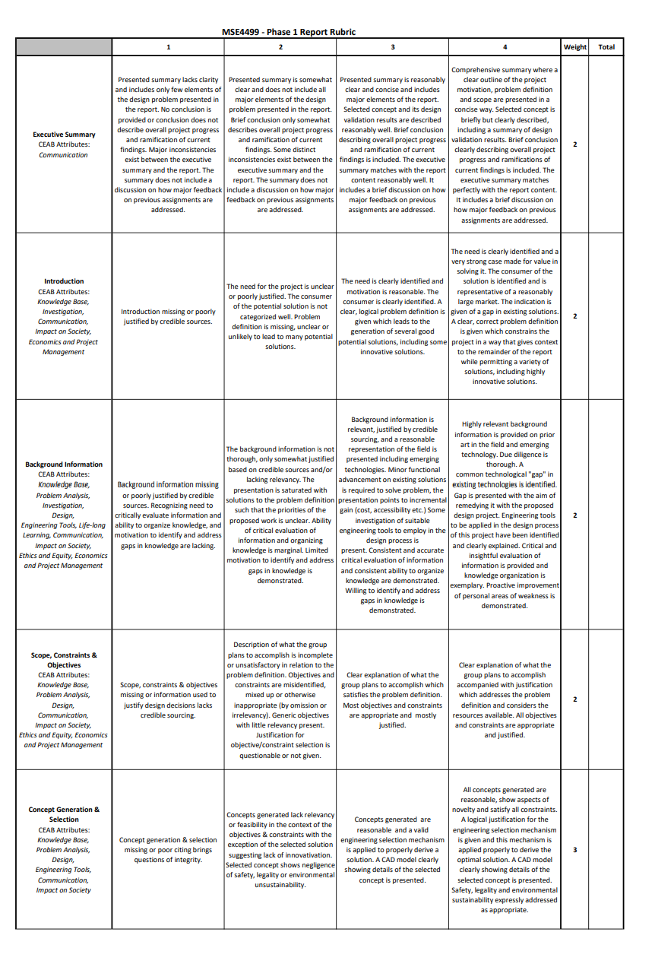

8

7

8

7

12

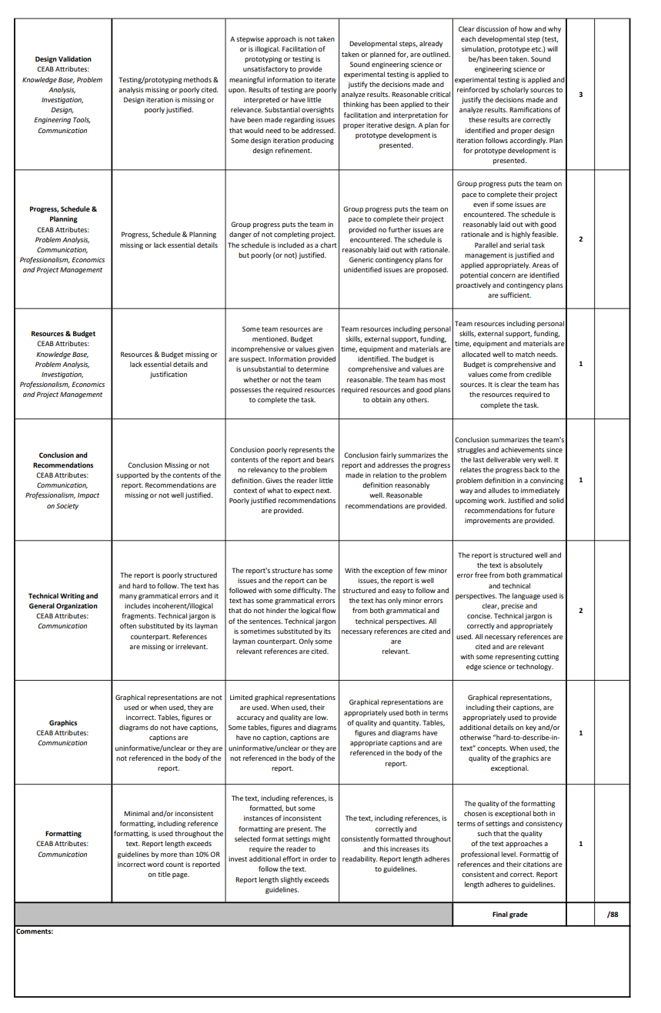

10

8

3

3

8

4

4

82